# Lab 2 – Automating Protections and Tracking Attacks

**Step 1: Associate WebCarter ALB with WAF-Automation Web ACL.**

1. Go to AWS WAF & Shield console, choose the region you’re working at, and open “WebCarter-lab1” Web ACL and navigate to the “Rules” tab on the right.
2. In “AWS resources using this web ACL” delete association with WebCarter ALB.
3. Choose WAF-automation Web ACL and open “Rules” tab.
4. Click “Add association”, then choose “Application load balancer” as “Resource type” and choose your WebCarter load balancer. Click “Add”.

Now your WebCarter Web application protected with Web ACL created by WAF-automation template.

**Step 2: Configure Web ACL full logging functionality.**

1. Open “Logging” tab of the WAF-automation Web ACL and click “Edit”.
2. Choose Kinesis Data Firehose stream created by waf-automation CloudFormation template.
3. Don’t add “Redacted Fields” and click “Create”.

**Step 3: Configure ElasticSearch with Kibana**

WAF Automation stack created Kinesis Firehose stream pointing to ElasticSearch domain. You will configure the Web ACL logging stream JSON WAF logs to the Kinesis Data Firehose.

Kinesis Data Firehose also places a backup copy of the WAF to an S3 bucket for Amazon Athena analysis.

Below you will create indexes and visualizations in your domain.

1. Go to ElasticSearch console, choose the domain created by waf-automation template, and click on the Kibana link:

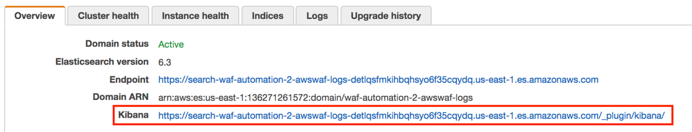

1. On the Kibana console click on “Get to work” and create an index using the following statement:

*PUT _template/awswaf-logs*

*{*

*"index_patterns": ["awswaf-*"],*

*"settings": {*

*"number_of_shards": 1*

*},*

*"mappings": {*

*"waflog": {*

*"properties": {*

*"httpRequest": {*

*"properties": {*

*"clientIp": {*

*"type": "keyword",*

*"fields": {*

*"keyword": {*

*"type": "ip"*

*}*

*}*

*}*

*}*

*},*

*"timestamp": {*

*"type": "date",*

*"format": "epoch_millis"*

*}*

*}*

*}*

*}*

*}*

Paste this statement in Kibana console and click on the green “play” bottom to execute it:

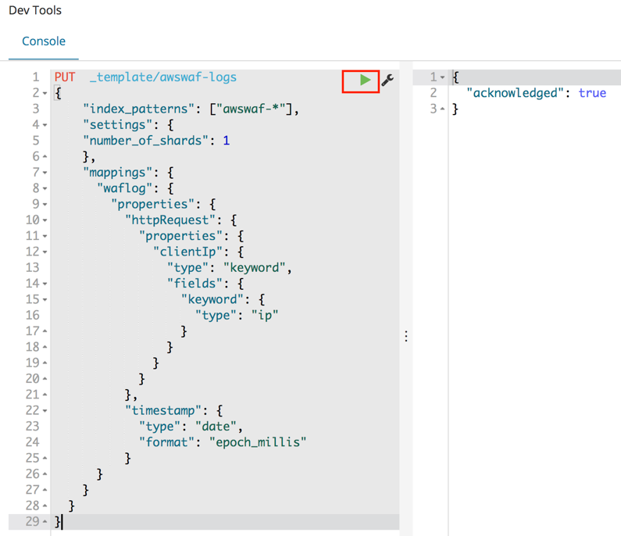

1. Click on the “Discover” menu, define an index pattern as *awswaf-\** and click “Next step”:

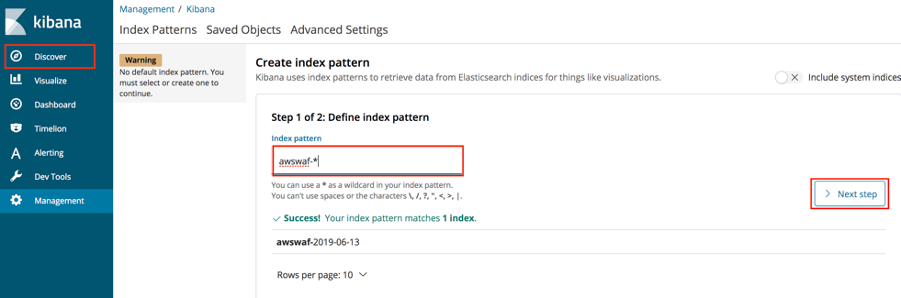

1. Choose timestamp as a Filter and click “Create index pattern”

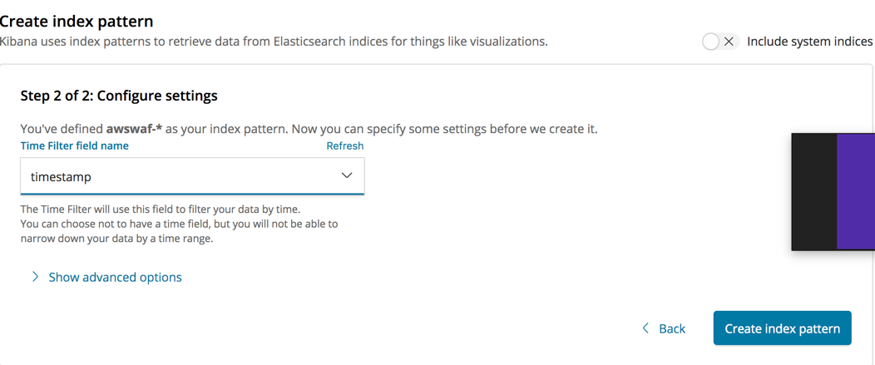

1. Now you’re able to run searches through your logs by going into the Discover tab in Kibana. For example, you can look for specific HTTP headers, query strings, or source IP addresses:

Now upload visualizations and a dashboard. You can always customize them or create your visualizations as required.

1. Go to “Management” menu and click “Advanced”. Search for the the defaultindex and copy and save the default index id value:

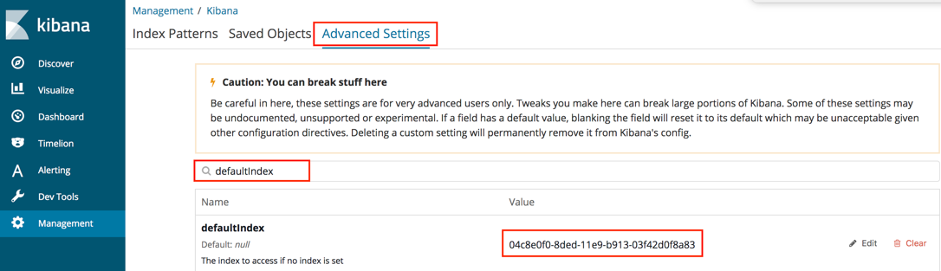

1. Open kibana-configruation.json file from the config directory on Github, and replace the *\"index\":\"d610d1f0-7136-11e9-a4df-61c3bd3f36bb\"* value with the one saved above. Please do it everywhere in the file.
2. Save the file.
3. Go to “Saved Objects” tab, click “Import” and upload the modified kibana-configruation.json file. Click “Yes” for the overwrite question.
4. You’ll see your dashboard and visualizations have been uploaded successfully:

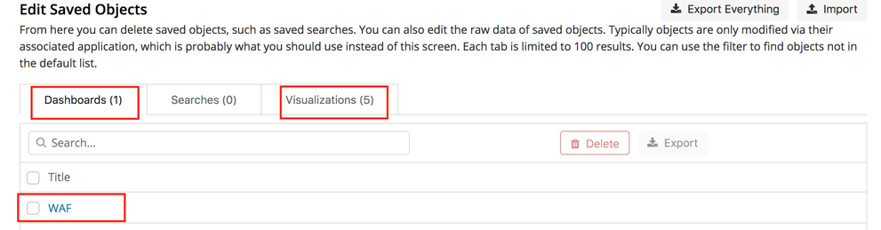

1. Navigate to the “Dashboard” menu and choose “WAF” dashboard you just uploaded.

You cannot see any data yet: we’ll start generating traffic in the next steps.

**Step 4: Use ElasticSearch Service with Kibana for WAF monitoring and forensics**

1. Run JMeter BOT1 scenario on the Windows instance to generate data for this exercise.
2. Go to AWS Console and choose ElasticSearch service. Choose your waf-automation domain and click on the Kibana link.
3. Navigate to the “Dashboard” menu on the right and explore the dashboard graphs. Check the number of requests per minute per source IP address.
4. Go to AWS WAF & Shield console, choose “IP addresses” menu and check if IP addresses you see in the Kibana charts appear in any of the block lists.

**QUESTION**: Should the source IP addresses for BOT1 scenario appear in any of the block lists?

This scenario simulates a mix of legitimate traffic together with under the radar BOT traffic.

1. Go back to Kibana “Dashboard” GUI and scroll down to “Allow/block URIs”. Note that /login page is one of the top requested URIs.
2. Go to “Discover” menu and enter the following search filter:

*httpRequest.uri:/user/login*

1. Scroll through some of the requests and note that at glance, they’re coming from the same source IP address.
2. Enter the following search filter.

*!httpRequest.uri:/user/login && httpRequest.clientIp:10.192.30.50*

**QUESTION**: *Do these requests look legit? In the real-life scenario why can we see large number of malicious and legitimate requests coming from the same IP address?*

*Can we just block all requests coming from that IP address?*

*Can we block all requests to this URI?*

1. Look at the User-Agent header value for the requests returned by the search below:

*httpRequest.uri:/user/login && httpRequest.clientIp:10.192.30.50*

Note that large number of requests has User-Agent value “IamaBOT”. We’ll create a WAF rule that blocks these requests below.

1. Go to AWS WAF & Shield console and navigate to “String and regex matching”.
2. Click “Create condition” and create BOT10 condition as following:

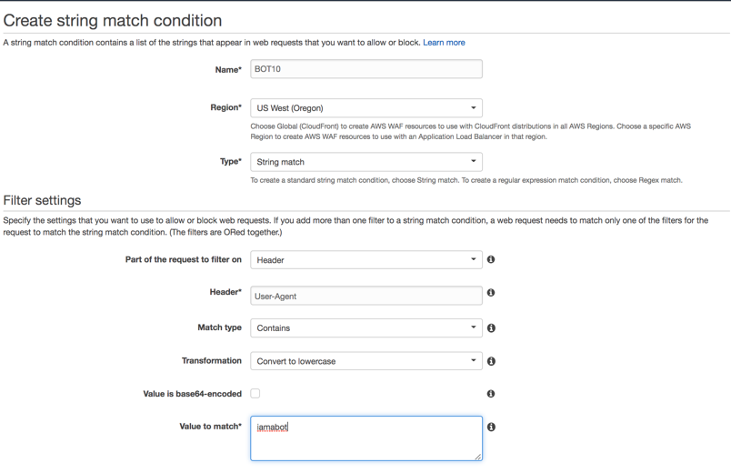

1. Click “Add filter” then “Create”.
2. Go to “Rules” menu and click “Create rule”.
3. Create BOT10 rule as following:

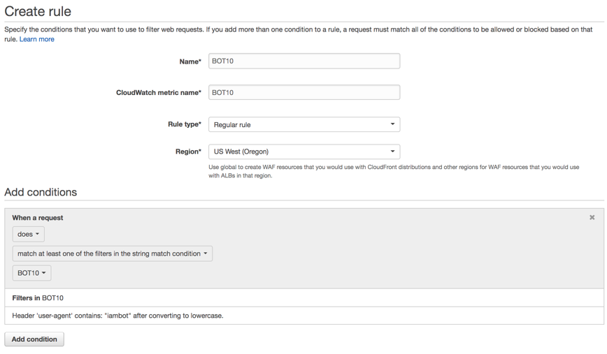

1. Click “Create”.
2. Navigate to “Web ACLs” menu and click on “WAF-Automation..” ACL.
3. Click “Rules” tab then “Edit Web ACL” button.
4. In the “Rules” drop-down list choose BOT10 rule and click “Add rule to Web ACL”.
5. Assure rule action set to “Block” and click “Update”.
6. Wait for couple for minutes and refresh Kibana dashboard. Check if you see blocked request to the login page.
7. Note the “Terminating Rule ID” in the “WAF Rules Hit” visualization and check the rule that block these requests. To do so, run the following AWS CLI command. Update the region and the rule id as required:

*aws waf-regional get-rule --region us-west-2 --rule-id d3458c9b-5bba-4361-a7ce-e28d66a86d27*

**QUESTION**: Does number of allowed requests to the login page look reasonable after we blocked a “IamABOT” BOT?

1. Enter the following filter and try to see if there is anything abnormal in the requests returned:

action:"ALLOW" && httpRequest.uri:"/user/login".

**QUESTION**: If we cannot find how to identify malicious requests and we cannot block this source IP entirely, what can be next steps of our investigation?

In the next steps we’ll look at ALB access logs using Amazon Athena.

1. Go to Amazon Athena AWS console.
2. Go to Query Editor and choose “awswafsecurityautomations..” as your Database.
3. Run the following SQL query:

SELECT * from app_access_logs where request_url like limit 1;

app_access_logs query points to the ALB access logs on the corresponding S3 bucket.

You can get an additional information about incoming requests from these logs, such as HTTP response code, SSL cypher and protocol, processing time. This information usually helps you to investigate incoming requests to your Web application.

1. Get familiar with the values returned.
2. Run the following SQL query:

*SELECT*

*client_ip,*

*request_url,*

*target_status_code,*

*COUNT(*) as counter*

*FROM*

*app_access_logs*

*WHERE*

*parse_datetime(time, 'yyyy-MM-dd''T''HH:mm:ss.SSSSSS''Z') > DATE_ADD('minute', -5, NOW()) AND*

*target_status_code = ANY (VALUES '400', '401', '403', '404', '405', '500')*

*GROUP BY*

*client_ip,*

*request_url,*

*date_trunc('minute', parse_datetime(time, 'yyyy-MM-dd''T''HH:mm:ss.SSSSSS''Z')),*

*target_status_code;*

As far we can see, there are malicious requests coming from the same IP address and targeting our Web appliucation REST API endpoint. We know that REST API shall be open only to our partners, and we decide quickly to block it for the IP address returned above.

1. Go to AWS WAF & Shield console and navigate to “String and regex matching”.
2. Click “Create condition” and create RESTAPI condition as following:

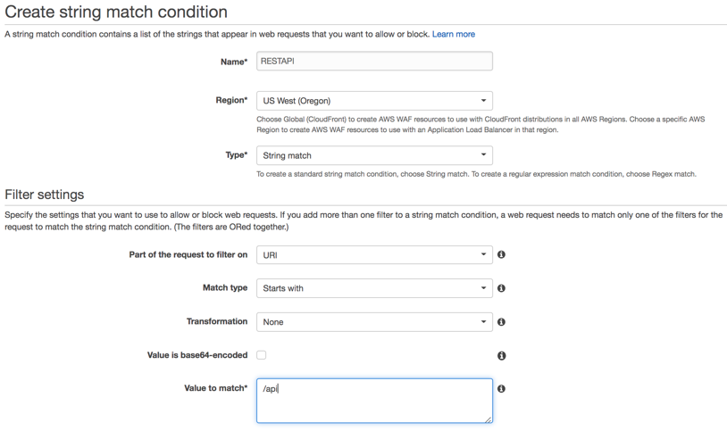

1. Click “Add filter” then “Create”.
2. Go to “IP addresses” and click “Create condition”:

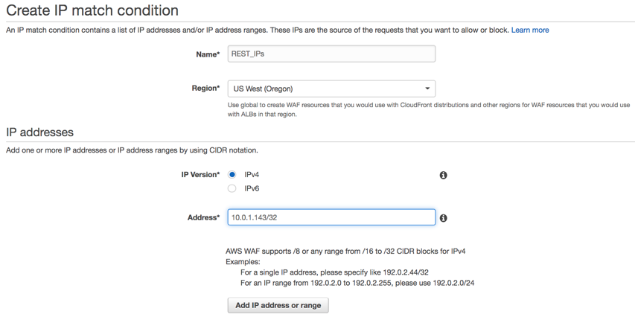

1. Click “Add IP address…” then “Create”.
2. Go to the “Rules” menu and click “Create rule”:

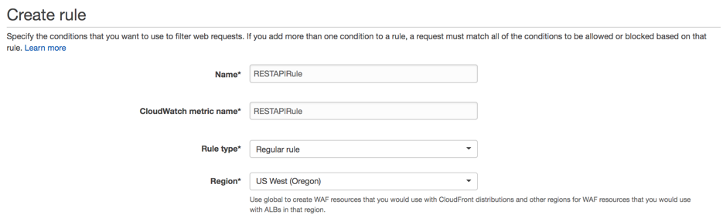

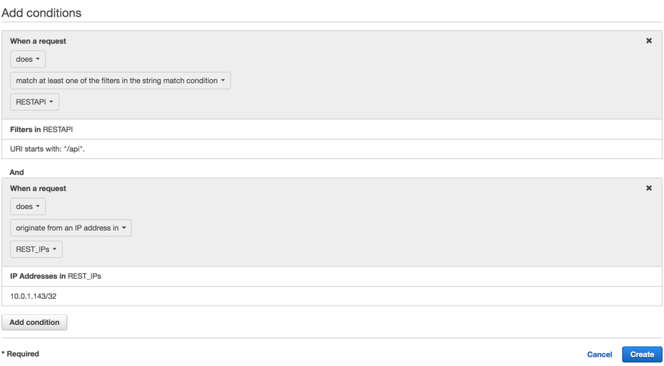

Note we added two conditions in this rule.

1. Navigate to “Web ACLs” menu and click on “WAF-Automation..” ACL.
2. Click “Rules” tab then “Edit Web ACL” button.
3. In the “Rules” drop-down list choose RestAPIRule rule and click “Add rule to Web ACL”.
4. Assure rule action set to “Block” and click “Update”.
5. Wait for couple for minutes and refresh your Kibana dashboard. Check if you see blocked request to the api endpoint.
6. Go to Athena console and run the following query:

SELECT

client_ip,

request_url,

target_status_code,

COUNT(*) as counter

FROM

app_access_logs

WHERE

parse_datetime(time, 'yyyy-MM-dd''T''HH:mm:ss.SSSSSS''Z') > DATE_ADD('minute', -5, NOW()) AND

elb_status_code = '403'

GROUP BY

client_ip,

request_url,

date_trunc('minute', parse_datetime(time, 'yyyy-MM-dd''T''HH:mm:ss.SSSSSS''Z')),

target_status_code

You can see that requests from that IP address to /api url been blocked by the WAF rule.

**Step 5: Honeypot for bad bots and scrapers.**

1. Open Chrome browser and navigate to the WebCarter home page.
2. Right click on the page and choose “Inspect”.
3. Verify the honeypot link is present on the page. This link has been inserted into your application by AWS Systems Manager, which was configured by WAF Automation CloudFormation stack.



WAF Automation CloudFormation stack configured an API Gateway instance with Lambda function that parses the source IP address of the request and adds the source IP address to the black list.

1. To review / customize the honeypot lambda function, go to AWS Console and choose API Gateway service.
2. Choose “Security Automation – WAF..” API and click “ANY”.
3. Click on the Lambda function on the right if you’d like to customize this function:

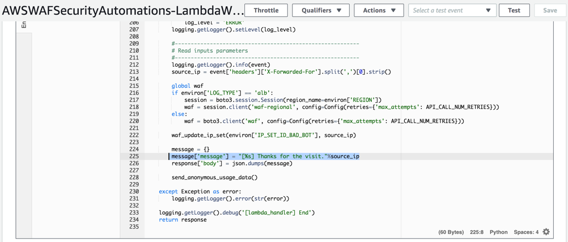

1. Run HTTTRack web copier on your Windows instance.
2. Click “Next” on the Welcome page and enter your project name (WebCarter for example):

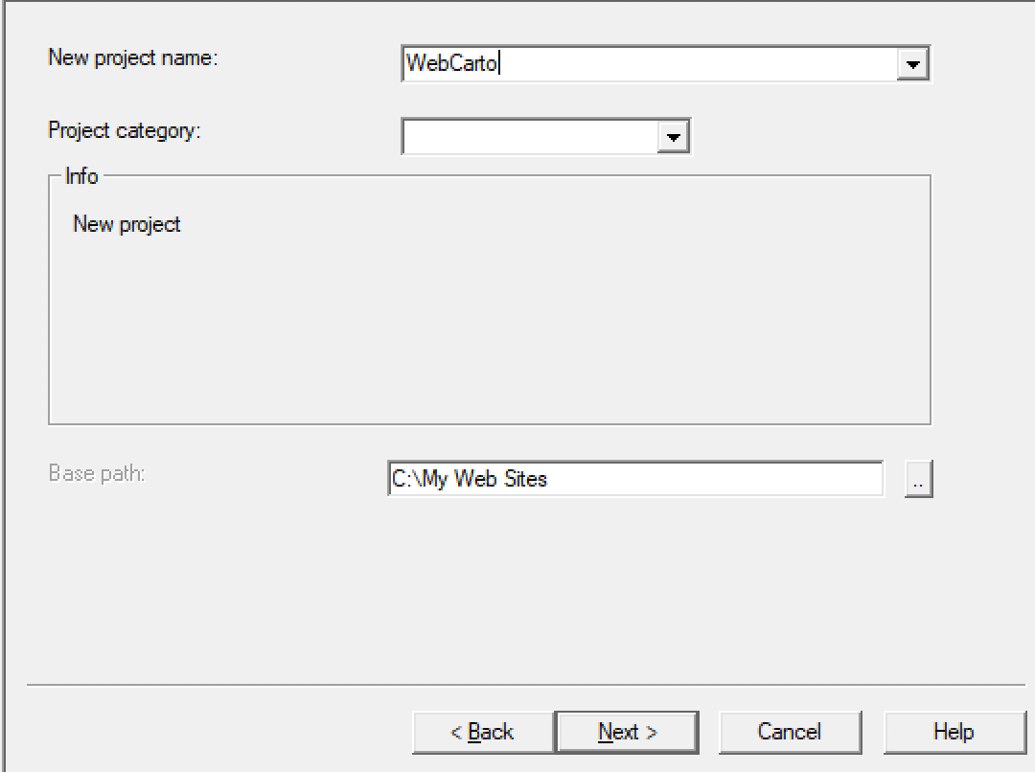

1. Click “Add URL”, enter the ALB endpoint and click “OK”:

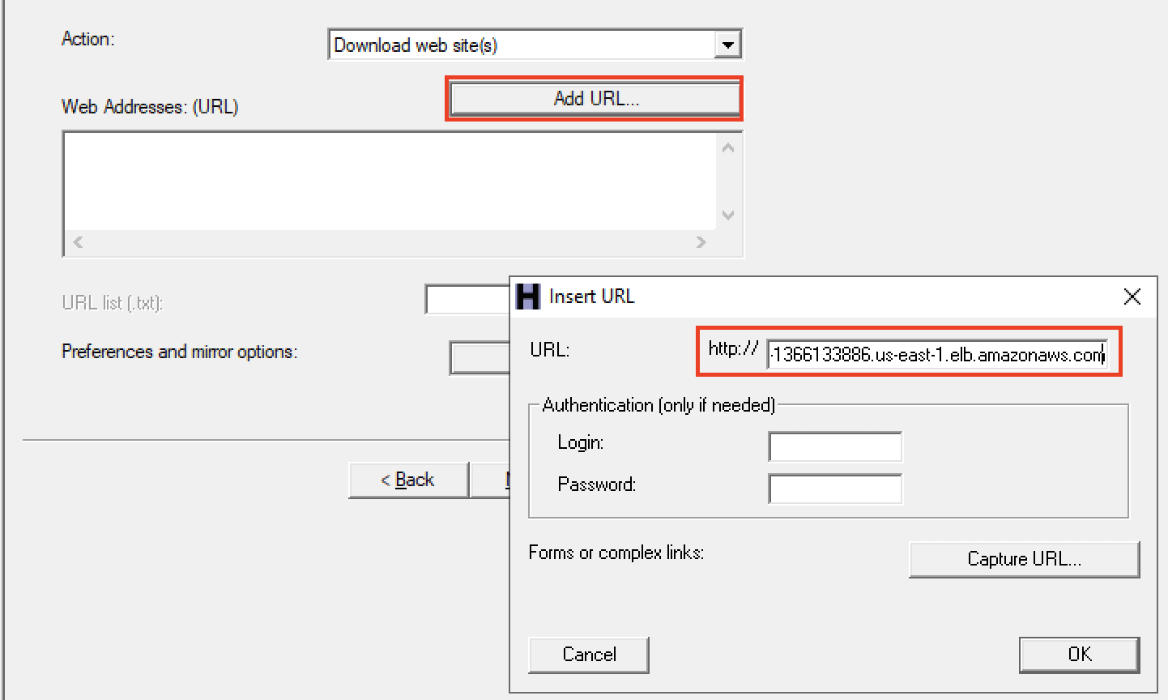

1. “Set options” button and go to “Experts Only” tab. Change “Global travel mode” to “Go everywhere…”. Due to out honeypot is on another domain, this will allow us to simulate a bad bot hitting the “no-follow” hidden honeypot link above:

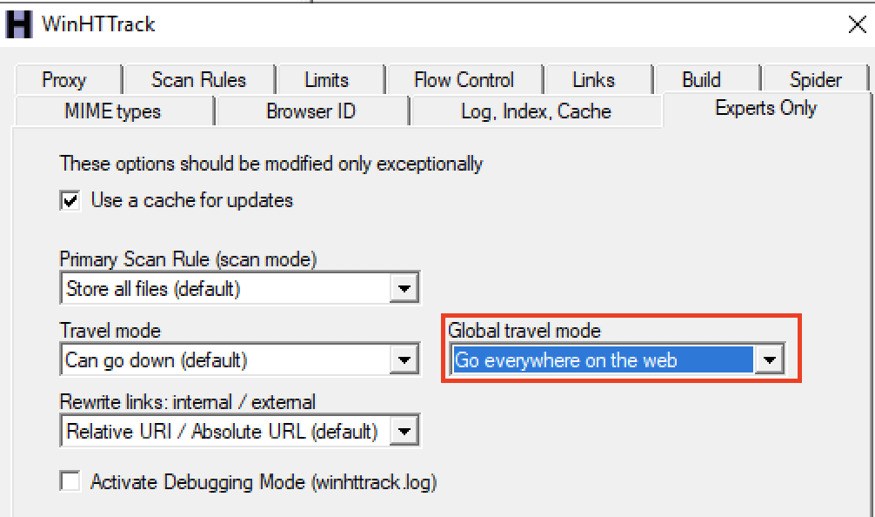

1. Click “Next” then “Finish”.
2. You can cancel the test after you see the site been downloading. It was enough time for the copier to follow the honeypot URL.
3. Navigate to WAF& Shield AWS Console, “IP Addresses” and choose “.. Bad Bot Set”. Assure you see your external IP address in the list.

**Note**: In this simulation HTTTrack is accessing an ALB using 10.x.x.x IP address, while accessing API GW honeypot endpoint using public IP address. Due to this simulation network topology, we can see our public source IP address been added to the block list by the Lambda function, although traffic from HTTTrack is not been blocked. In the real-life scenario scraper will be blocked based on its public IP address.

**Step 3: WAF Automation using AWS Lambda and Amazon Athena.**

In the above steps we demonstrated manual creation of the WAF rules using information we’ve got from Kibana dashboard and Athena SQL queries. Below we’ll work with automated protection configured by WAF Automation CloudFormation template.

1. Go to WAF & Shield AWS Console, IP Addresses and click on “.. Scanners & Probes Set”.
2. Assure the list is currently empty.
3. Go to Amazon Athena console and navigate to “Saved Queries” tab.
4. Click on “ScannersProbesLogParser” query.
5. For our exercise, change the time window from 240 minutes to 5 minutes:

*DATE_ADD('minute', -5, NOW())*

Now this modified query will be looking for any IP address that got >=50 of the 4xx responses from the application within last 5 minutes.

1. Click “Save as” and save the modified function with the new name “ScannersProbesLogParser5min”.
2. In AWS CLI run the following command updating the region as required (here and in all commands below):

*aws athena list-named-queries --region us-west-2*

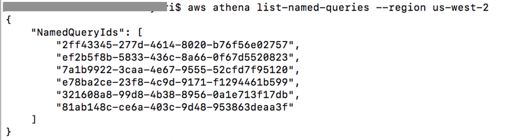

1. Copy the id of the first query in the list and run the following command with that query id:

aws athena get-named-query *--region us-west-2* --named-query-id 2ff43345-277d-4614-8020-b76f56e02757

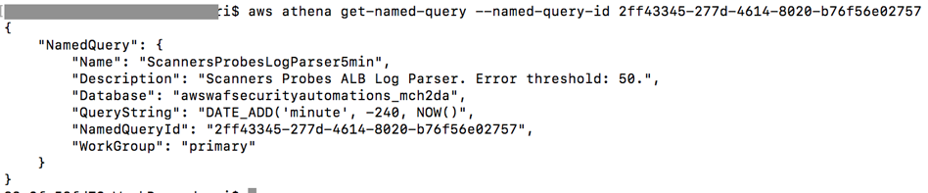

1. Check the query name and assure this is the query we just saved on the console.
2. Go to AWS Lambda console and search for “[LambdaLogParserFunction](https://us-west-2.console.aws.amazon.com/lambda/home?region=us-west-2#/functions/AWSWAFSecurityAutomations1-LambdaLogParserFunction-OF5T61R0EN0C)”.
3. Open “LambdaLogParserFunction” and click on the “CloudWatch Events”.
4. Click on “…LambdaAthenaAppLogParser…” one.
5. In the CloudWatch window click “Action->Edit” on the top right corner.
6. In the JSON input definition scroll right and replace the query id with the one you saved above:

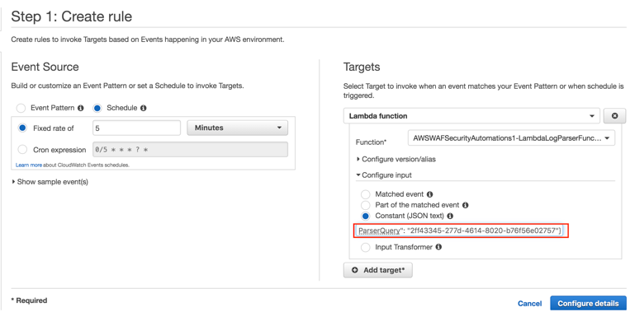

1. Click “Configure details” and then “Update rule”.
2. Run “Scanners and Probes” scenario on JMeter.
3. Go to the results tree in JMeter and verify that application returns 404 “Not found” response.
4. After about 5 minutes go to AWS WAF & Shield console, navigate to “IP addresses” and click on “…Scanners & Probes Set”. Verify that your source IP address appeared in the blocking list.
5. Go to JMeter results tree, clear the results and check that currently JMeter is getting HTTP 403 “Forbidden” response from WAF.
6. Stop JMeter test and check that in about 5 minutes your source IP address will disappear from the “…Scanners & Probes Set” IP list.

In this scenario we used automated detection of probes and scanners, that are getting 4xx responses from the application and stay undetected by the rate-limiting rules.